Part 1: I made a folder in workspace for github this has the pictures folder and this document inside
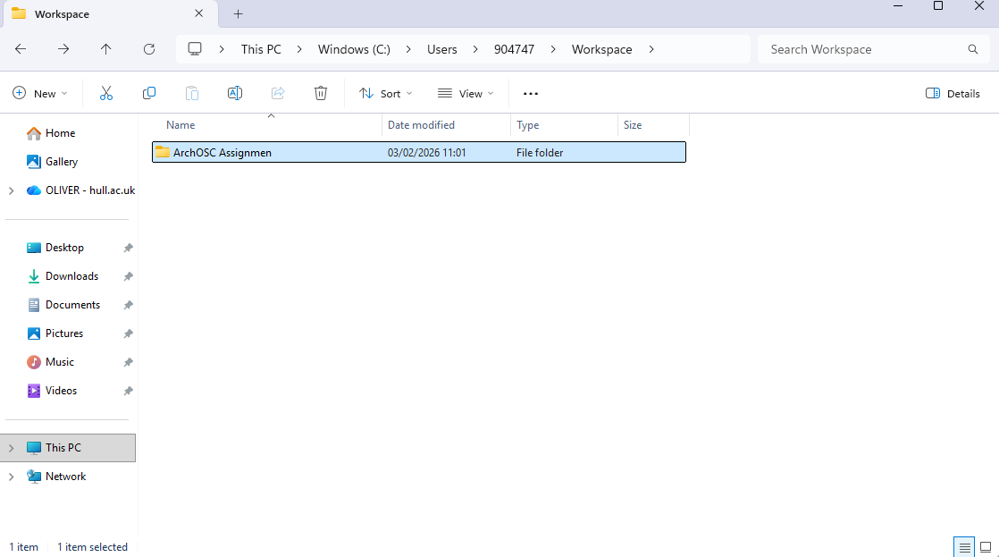

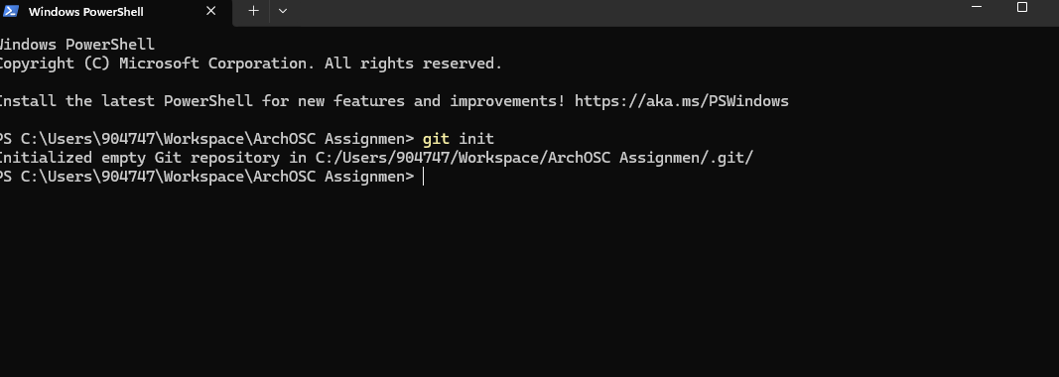
part 2: I opened the terminal in my and typed the git init command

part 3: created a repository on github
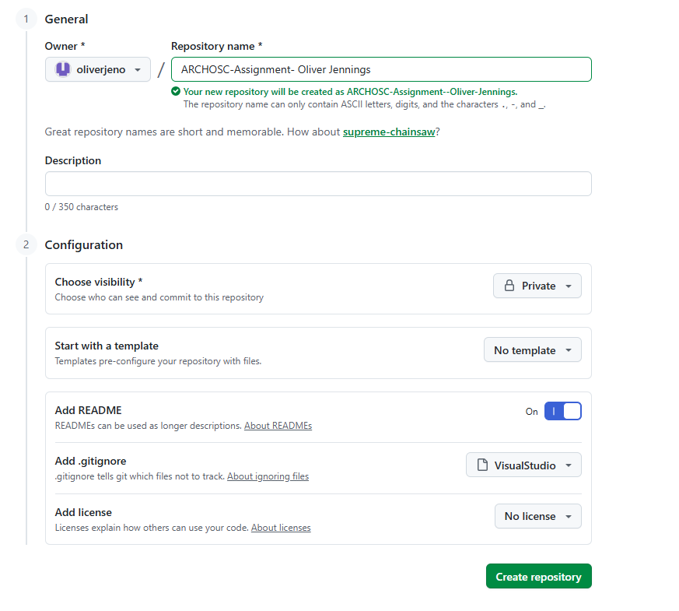

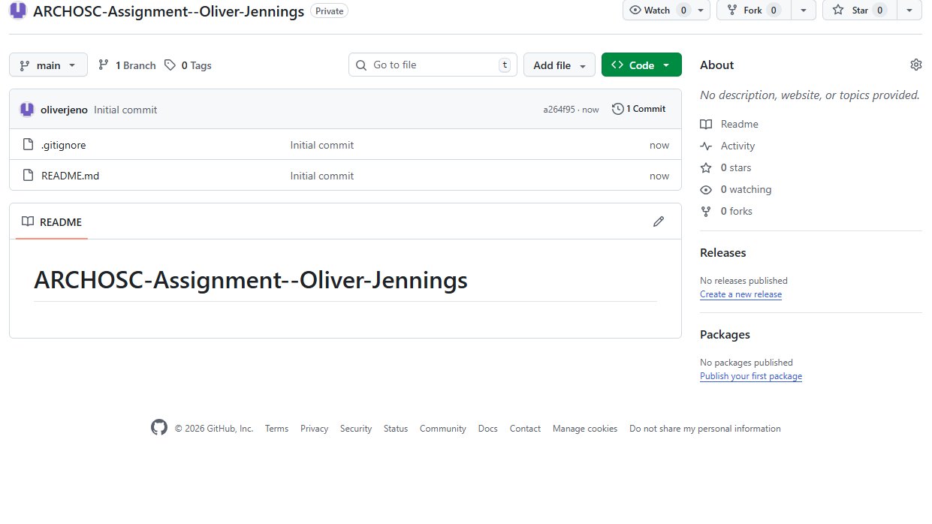

Part 4:I added my GitHub repository as a remote repository to my pictures folder, and I pulled my information from github to my computer
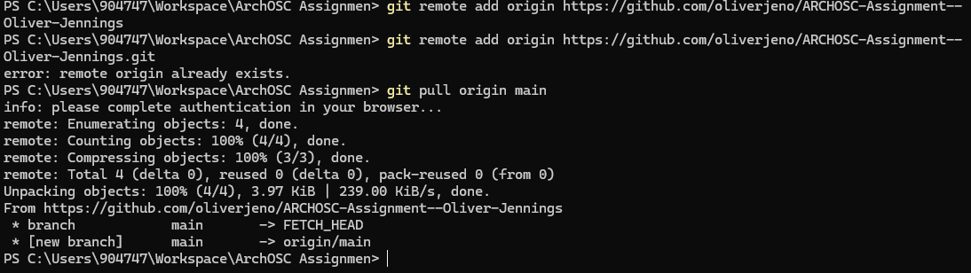
Part 5: I used visual studio to make my website
